
Victims of Crime Assistance Rules 2010
Form 1 Rule 6

APPLICATION FOR ASSISTANCE
Victims of Crime
Assistance Tribunal
1. DETAILS OF PERSON WANTING ASSISTANCE
Surname |  |  |  |  |  |  |  |  |  |  |  |  |  |  |  |  |  |  |  |  | Given Names
Address
 |  |  |  |  |  |  |  |  |  |  |  |  |  |  |  |  |  |  |  |  | Postcode
Telephone |  | (H) |  |  |  |  |  |  | (W)
 |  | (M)
Occupation |  |  |  |  |  |  |  |  |  |  |  |  |  |  |  |  |  |  |  |  | Date of Birth
Gender |  | Male Female Indeterminate/Intersex/Unspecified
Email
Are you of Aboriginal or Torres Strait Islander origin?
Persons of both Aboriginal and Torres Strait Islander origin should mark both “Yes” boxes
No Yes, Aboriginal Yes, Torres Strait Islander
A person of Aboriginal or Torres Strait Islander origin means a person who is descended from an Aboriginal or Torres Strait Islander; and is accepted as an Aboriginal or Torres Strait Islander by an Aboriginal or Torres Strait Island community.
This information will enable the Tribunal to provide you with information to assist your application
Have you previously made an application for assistance/criminal compensation? Yes No
Have you previously made an application in respect of this act of violence? Yes No
Please nominate which category applies to you
1. | Primary Victim
Please note:
You can only apply in one category
2. | Secondary Victim
3. | Related Victim
4. | Application for payment of Funeral Expenses only
2. COMPLETE THIS SECTION IF YOU ARE MAKING THIS CLAIM ON BEHALF OF A CHILD OR PERSON UNDER DISABILITY
Your Full Name
Address
Postcode |  |  |  |  |  |  |  | Telephone |  |  |  |  |  |  |  |  |  |  |  |  |  |  | Date of Birth
Email
Relationship to Applicant (e.g. I am their parent, guardian)
3. CIRCUMSTANCES OF THE ACT OF VIOLENCE
What was the act of violence/offence?
At what address did the act of violence occur?
Date of act of violence |  |  |  |  |  |  |  |  |  | Or between |  |  |  |  |  |  |  |  |  |  | and |  |  |  |  |  |  |  | Time |  |  | am/pm
Who committed the act of violence (full name if known)?
Sex of alleged offender Male Female |  |  |  |  |  |  |  |  |  |  |  |  |  |  |  | Date of Birth or approximate age
Was the alleged offender a family member or domestic partner of the victim?* Yes No
If Yes, how are you related to the offender? I am their:
(e.g. wife, son, father, step-sister, former domestic partner)
(* This information is for data collection purposes only)
If more than two years have lapsed since the act of violence please outline your reasons for not filing an application within this time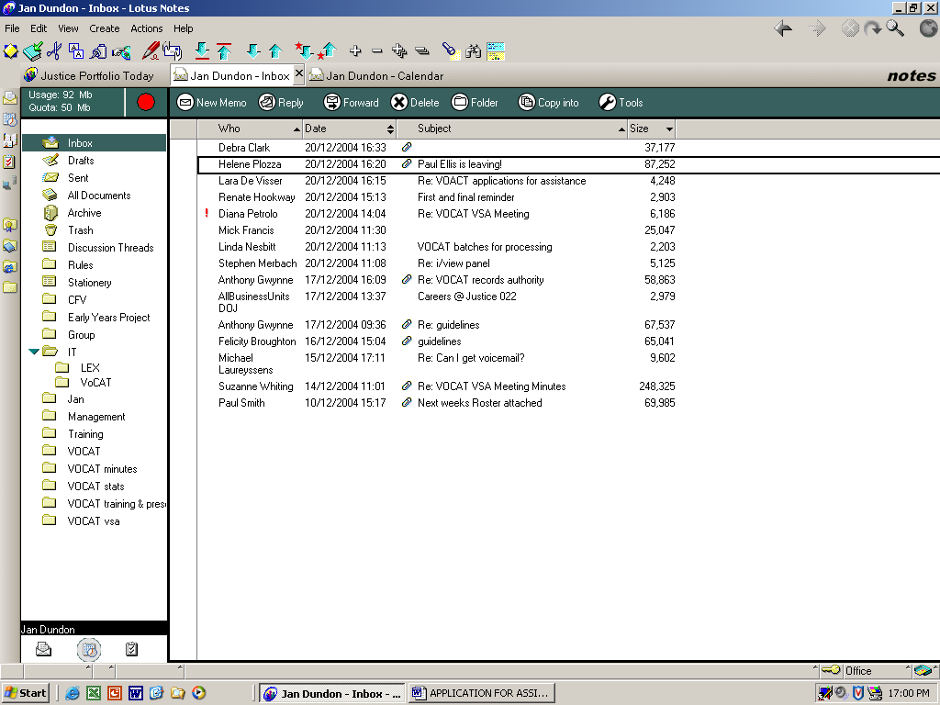please attach additional material if required:

4. REPORTING DETAILS
Has the act of violence been reported to the Police? Yes No
If yes, please provide the details:
Name |  |  |  |  | Registered No
Rank |  |  |  |  | Police Station
Date of Report
If no, you must provide a statutory declaration setting out the circumstances of the act of violence and provide the reason for the failure to report the matter to police.
Statutory Declaration attached? Yes No
Have criminal proceedings commenced? Yes No Unknown
If known, provide details known to you (i.e. date and location of hearing)
Are there intervention orders relating to this matter? Yes No Case number (if known)
If the incident occurred in the workplace, was it reported to your employer? Yes No
Has the act of violence been reported elsewhere? Yes No
If yes, please provide the details:

5. WHAT EFFECTS HAVE RESULTED FROM THE ACT OF VIOLENCE?
Physical * Yes No
Psychological * Yes No
Grief, Stress or Trauma Yes No
Provide details
Did you attend a hospital Yes No
If yes, what hospital?

6. DETERMINATION OF YOUR APPLICATION
Would you prefer to: |  | Attend a hearing at the Tribunal? OR
 |  | Have your application determined in your absence?
Do you request that: |  | Proceedings be conducted in a closed Court?
 |  | Publication of your application be restricted?
Do you require an interpreter Yes No |  |  |  |  | Language
If the Tribunal makes an award would you like it deposited directly into your bank account?
No (if no selected a cheque will be sent to your postal address, please ensure this is current at all times)
Yes | Account name |  |  | BSB number |  |  |  |  | Account number
 | Name of Bank/Financial Institution

7. HAVE YOU APPLIED FOR ASSISTANCE UNDER ANY OTHER SCHEMES?
Yes No |  | If “Yes”, complete this section
Have you received assistance under the Victims Assistance Program No

Yes Please provide details
 |  | Still Pending |  |  | Finalised |  |  | Amount Received |  |  | Ref/Claim No
Workcover
Transport Accident Commission
Insurance (eg. Health, income etc)
National Redress Scheme
Civil Proceedings/Sentencing
Other (please specify)
Please provide details of the claim under any of these schemes
Please supply and attach details of any relevant insurance cover (life or health) or superannuation benefit entitlements held and any payments claimed, received or to be received -
By the applicant provide details |  |  |  | By the deceased provide details

8. TYPE OF ASSISTANCE SOUGHT
(a) Primary Victim | Special Financial Assistance (lump sum payment for significant adverse effects suffered)
 | Counselling
 | Medical Expenses
 | Safety-Related Expenses
 | Loss of Earning
 | Loss/Damage to clothing
 | Other
(b) Secondary Victim | Counselling
 | Medical Expenses
 | Loss of Earnings *
 | Other *
(c) Related Victim | Distress
 | Funeral Expenses
 | Counselling
 | Medical Expenses
 | Other *
(d) Application for payment of funeral expenses only
* Evidence of exceptional circumstances may be required.

9. IF DEATH WAS CAUSED BY THE ACT OF VIOLENCE
Full Name of Deceased
Last Known Address
 |  |  |  | Postcode
Date of Birth |  | Your relationship to the deceased,  I am their:(e.g.wife, son, father, step-sister, partner)
Date and Place of Death
NOTE: YOU MUST ALSO COMPLETE THE RELATED VICTIMS PART OF THIS FORM BELOW

10. THIS SECTION IS TO BE COMPLETED BY RELATED VICTIM APPLICANTS
As a related victim applicant (see definition of Related Victim) you are required to list:
(a) every other person whom you believe may be a related victim; and
(b) every other person whom you believe may alleged that he/she is a related victim; and
(c) Any person whom you believe may apply because they have incurred funeral expenses as a result of the death of the primary victim.
Attach a separate sheet if required.
Name of potential victim
Age of potential victim if under 18 years of age *
Guardian (if applicable)
Address of potential victim
What was the relationship of potential victim to the deceased. He/she is their:
Name of potential victim
Age of potential victim if under 18 years of age *
Guardian (if applicable)
Address of potential victim
What was the relationship of potential victim to the deceased. He/she is their:
Name of potential victim
Age of potential victim if under 18 years of age *
Guardian (if applicable)
Address of potential victim
What was the relationship of potential victim to the deceased. He/she is their:
* If the potential victim is under 18 years of age, provide the name and address of parent, guardian or administrator.

11. AUTHORISATION OF THE APPLICANT
I (name), |  |  |  |  |  |  |  |  |  | authorise the Victims of Crime
Assistance Tribunal to obtain any additional evidence or documentation that the Tribunal considers necessary to enable it to determine my application.
 |  |  |  | x
Signature of applicant
12. ACKNOWLEDGMENT
I understand and acknowledge that:
- To the best of my knowledge, all information provided in this application is true and correct and that no details relevant to the application have been left out
- It is an offence under section 67 of the Victims of Crime Assistance Act 1996 to knowingly give false or misleading information to the Victims of Crime Assistance Tribunal.
 | By ticking this checkbox I confirm that I have read and understood all the statements above
Full name of person completing this application
Signature
Date

Oaths and Affirmations (Affidavits, Statutory Declarations and
Certifications) Regulations 2018
S.R. No. 152/2018

STATUTORY DECLARATION
(Section 30 of the Oaths and Affirmations Act 2018)

I, of [address] , [occupation] ,
make the following statutory declaration under the Oaths and Affirmations Act 2018:

I declare that the contents of this statutory declaration are true and correct and I make it knowing that making a statutory declaration that I know to be untrue is an offence.

____________________________ [signature of person making this statutory declaration in the presence of the authorised statutory declaration witness]
Declared at [place]
in the State of Victoria on
I am an authorised statutory declaration witness and I sign this document in the presence of the person making the declaration:

____________________________ [signature of authorised statutory declaration witness]
on

[full name and personal or professional address of authorised statutory declaration witness in legible writing, typing or stamp]
[qualification as an authorised statutory declaration witness]
*I confirm that reasonable modifications were used in preparing this statutory declaration and that the contents of this statutory declaration were read to the person making the statutory declaration in a way that was appropriate to the person's circumstances.

____________________________ [signature of authorised statutory declaration witness]

A person authorised under section 30(2) of the Oaths and Affirmations Act 2018 to witness the signing of a statutory declaration. *delete if not applicable

